1st December 2017

**YOKOHAMA UK Subsidiary Receives Two Awards for Its Efforts to Promote Tyre Safety**

YOKOHAMA’s U.K. sales and marketing subsidiary Yokohama H.P.T. Ltd. (YHPT) has been honored for its tyre safety promotion activities by two separate organizations in the United Kingdom. YHPT received the “Tyre Manufacturer of the Year” award presented by TyreSafe, a nonprofit organization promoting tyre safety, at the TyreSafe Awards 2017 ceremony held in July this year. YHPT accepted the award for a second straight year. In October, YHPT received the “Industry Marketing Campaign of the Year” from the U.K.’s National Tyre Distributors Association (NTDA), a trade association representing and promoting the interests of the tyre wholesale, distribution and retail sectors of the automotive after-care market, at 2017 NTDA Tyre Industry Awards ceremony.   
  
The awards are a recognition of the activities undertaken together with Chelsea FC in 2016 as part of YOKOHAMA’s official shirt partnership with the English Premier League football club. Those activities included the posting of “Safe tyres save lives” safety-awareness messages on the giant electronic screen at Chelsea FC’s home games and the use of the internet and other digital communications media to transmit tyre safety messages, including via YHPT and Chelsea FC social networking sites. As a result, the tyre safety message reached thousands of football fans.   
  
In addition, Chelsea FC has become the first, and only, professional football club to become an official supporter of TyreSafe.

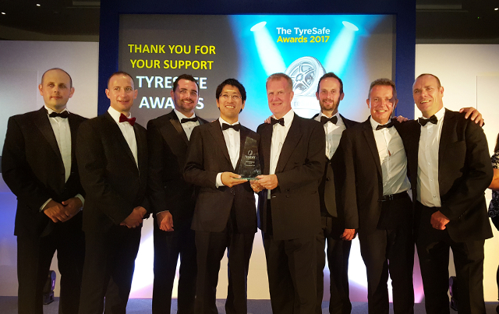

*Award ceremony scenes at the TyreSafe Awards 2017*

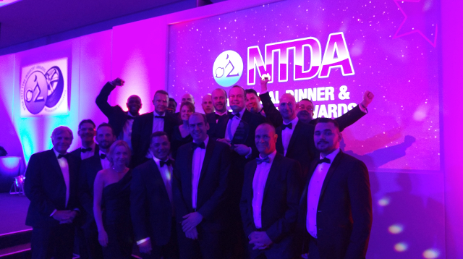

*Award ceremony scenes at 2017 NTDA Tyre Industry Awards*